**Data engineering syntax assessment (14 pts total)**

**Question 1 (8 points)**

**Answer the questions only in Python and upload your code file (Jupyter Notebook or *.py file) to a repo on github and share the link**

A U.S graduate school has students from Asia, Europe, and America. The students' continents of origin and colleges are stored in a data frame STUDENTS. You can assume that there may be duplicate records, as shown below:

| name | continent | college |

|--------|-----------|-------------|

| Andy | America | Lib Arts |

| Jose | Europe | Business |

| Dieu | Asia | Engineering |

| Chloe | America | Engineering |

| Jose | Europe | Business |

Please write R or Pandas code to create a new data frame COUNTS that counts the number of unique student records corresponding to each continent, college pair. Lay out the data in a 3x3 grid with colleges sorted reverse alphabetically on the vertical axis. The horizontal axis does not need to be sorted. Null values should be zero-filled. For the sample input, the desired output would be:

| continent | America | Asia | Europe |

| college |---------|------|--------|

| Lib Arts | 1 | 0 | 0 |

| Engineering | 1 | 1 | 0 |

| Business | 0 | 0 | 1 |

**A) Write R or Pandas code to de-dup STUDENTS (1pt):**

**B) Create a data frame COUNTS storing the count of students for each continent, college pair (2pts):**

**C) Pivot COUNTS so that continent values become column names (2pts)**

**D) If applicable, remove any unnecessary index levels created in part C (1pts):**

**E) Zero-fill missing values in COUNTS (1pt):**

**F) Sort COUNTS reverse alphabetically by college name (1pt):**

**Question 2 (6 points)**

**Choose either Python or R for the entirety of this question.**

**Python:**

1. **Select the answer to complete the assigned task (2pts)**

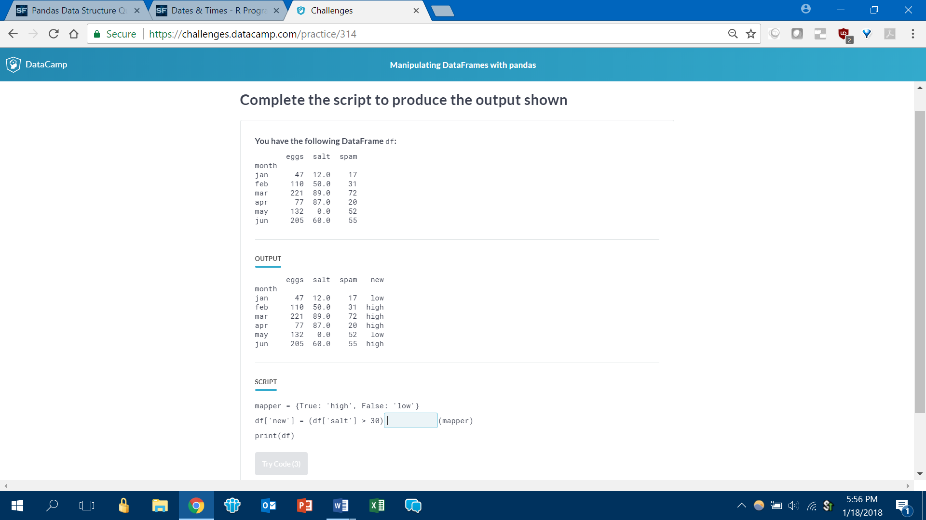

Of the months April, May, and June, calculate how many had eggs>100

A) (df.loc[[‘apr’, ‘may’, ‘jun’],][‘eggs’] > 100).sum()

B) (df[[‘apr’, ‘may’, ‘jun’],][‘eggs’] > 100).sum()

C) (df[[‘apr’,’may’,’jun’]][‘eggs’] > 100).sum()

D) (df[(‘apr’, ‘may’, ‘jun’),][‘eggs’] > 100).count()

1. **Complete the script to produce the output shown (2pts)**

Output

datetime.date(2018, 1, 1)

Script

import datetime

datetime.datetime._______(‘01012018’, “%d%m%Y”)________

A) strptime, .date()

B) strptime, .as.date()

C) to_date, [Nothing]

D) to_datetime, [Nothing]

**C) Select the correct script to accomplish the task (2pts)**

Following is a summary of the iris dataset:

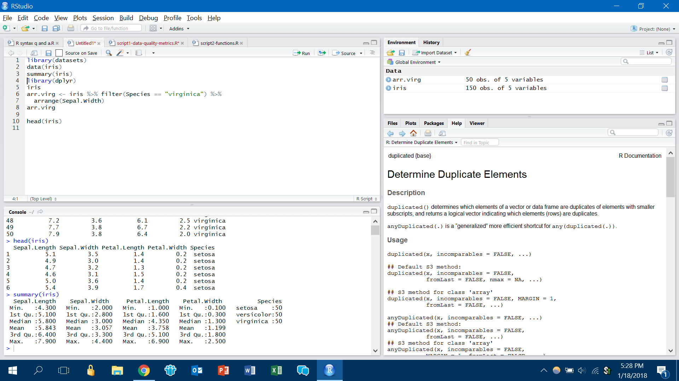

How would you create a new object with:

* only the “setosa” species
* Petal.Width greater than 2
* Sorted by Sepal.Length in descending order

1. iris[(iris[‘Species’] == ‘setosa’) && (iris[‘Petal.Width’] > 2)].sort_values(‘Sepal.Length’, ascending = False)
2. iris.loc[(iris[‘Species’] == ‘setosa’) & (iris[‘Petal.Width’] > 2)].sort_values(‘Sepal.Length’, ascending = False)
3. iris.loc[(iris[‘Species’] == ‘setosa’) & (iris[‘Petal.Width’] > 2)].sort_values(‘Sepal.Length’, desc)
4. iris[(iris[‘Species’] == ‘setosa’) & (iris[‘Petal.Width’] > 2)].sort_descending(‘Sepal.Length’)

**R:**

1. **Select the answer to complete the assigned task (2pts)**

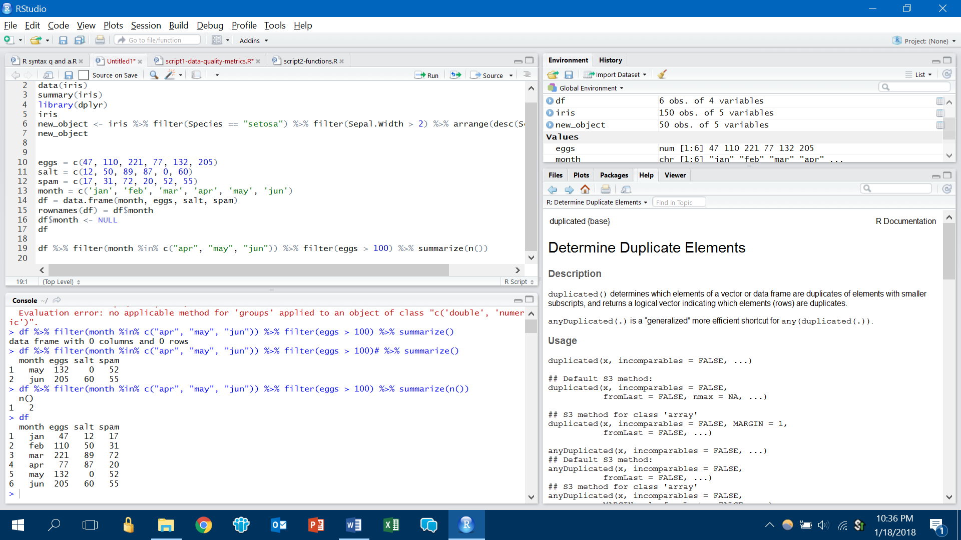

A) df %>% select(month is.in("apr", "may", "jun")) %>% filter(eggs > 100) %>% summarize(count())

B) df %>% filter(month is.in("apr", "may", "jun")) %>% filter(eggs > 100) %>% summarize(n())

C) df %>% filter(month %in% c("apr", "may", "jun")) %>% filter(eggs > 100) %>% summarize(n())

D) df %>% filter(month %in% c("apr", "may", "jun")) %>% filter(eggs > 100) %>% summarize(count())

1. **Complete the script to produce the output shown (2pts)**

Output

[1] “2000-06-09”

Script

x <- “9_June_2000”

_______(x, format = “%d_%B_%Y”)

A) Date

B) as.POSIXct

C) as.Date

D) as.date

E) as.DateTime

**C) Select the correct script to accomplish the task (2pts)**

Following is a summary of the iris dataset:



How would you create a new object with:

* only the “setosa” species
* Petal.Width greater than 2
* Sorted by Sepal.Length in descending order

A) new_object <- filter(iris, Species == “setosa”) %>% filter(Petal.Width > 2) %>% sort(Sepal.Length, TRUE)

B) new_object <- select(iris, Species == “setosa”) %>% filter(Petal.Width > 2) %>% sort(Sepal.Length, desc)

C) new_object <- iris %>% filter(Species == "setosa") %>% filter(Petal.Width > 2) %>% arrange(desc(Sepal.Length))

D) new_object <- iris %>% select(Species == "setosa") %>% filter(Petal.Width > 2) %>% arrange(Sepal.Length, desc)